Geog 777 — Project 1 Report
October 11, 2025
Sonja Sebree
Abstract
This project develops and demonstrates a reproducible workflow that examines the association between nitrate concentration in groundwater and cancer risk at the census tract scale in Wisconsin. The solution combines an ArcPy backend and a Tkinter graphical interface within ArcGIS Pro. The workflow interpolates well nitrate measurements using inverse distance weighting, aggregates the surface to tracts with zonal statistics, estimates a tract-level linear model using Ordinary Least Squares, and assesses spatial autocorrelation of residuals with Moran’s I. The application allows a user to specify the IDW power parameter $K$, execute the analysis end to end, and review maps and reports. The design balances methodological rigor and practical usability for agency staff.
Project Scenario and Objectives
I approached the problem as a GIS analyst at the Wisconsin Department of Natural Resources. The department provided two datasets, recent well tests with nitrate values and cancer rates summarized by census tract. The objective was to build a small, dependable application that a colleague could run without additional setup. The tool needed to accept a user supplied $K$for IDW, run the entire pipeline, and present outputs that support interpretation and communication.
Data and Preprocessing
- Inputs: well point features that store nitrate concentration, and census tract polygons that store cancer rates.
- Spatial framework: a consistent projected coordinate system was used for analysis.
- Raster resolution: cell size was chosen to ensure that at least one raster cell center falls inside every tract, since zonal statistics reads values at cell centers. This avoided missing summaries in small tracts.
Methods
- Interpolation to continuous surface: Nitrate measurements at well locations were transformed into a continuous surface using inverse distance weighting. The interface passes the user’s $K$value to the power parameter, which controls distance decay. Larger $K$increases the weight of nearby wells relative to distant wells.
- Aggregation to tract scale: Zonal Statistics as Table computed the mean nitrate concentration for each tract from the IDW raster. The finer cell size eliminated empty summaries in small tracts.
- Model estimation: An Ordinary Least Squares regression related tract cancer rate to tract mean nitrate. Model fit and coefficient estimates were exported to a report.
- Diagnostic assessment: Spatial Autocorrelation, Moran’s I, was applied to OLS residuals to evaluate the independence assumption. Significant clustering indicates a need for spatial regression or additional covariates.
Application Design and Architecture
The application runs entirely inside the ArcGIS Pro Python environment, which simplifies deployment to staff who already have Pro installed.
- Backend, ArcPy: manages IDW, Zonal Statistics, OLS, and Moran’s I. The arcpy.mp module refreshes map layouts in a prebuilt ArcGIS Pro project and exports figures and reports.
- Frontend, Tkinter: provides a single field for $K$, a Run Analysis button, map switching controls, and one click access to the OLS and Moran’s I reports. A process log communicates progress and errors during execution.
- Separation of concerns: the geoprocessing script and the GUI script are independent. This reduces schema lock issues, keeps the interface responsive, and simplifies debugging.
Outputs
The tool writes consistent artifacts to an images directory for easy comparison across runs.
- Maps: an IDW surface PNG and optional layout based visualizations for OLS and Moran.
- Reports: an OLS report as PDF and a Moran’s I summary as HTML.
- Filename convention: periods in the $K$value are replaced with underscores, for example $K=2.5$yields idw_map_k2_5.png, OLS_2_5.pdf, and MoranReport_2_5.html. This convention improves sorting and side by side review.

Results and Interpretation
Ordinary Least Squares (OLS) linear regression estimates the relationship between one or more independent variables (predictors) and a dependent variable (response). It accomplishes this by fitting a linear equation to observed data. Here is what that equation looks like:
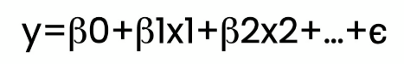
- where: y is the dependent variable.
- x1, x2,…, are independent variables.
- β0​ is the intercept.
- β1, β2, …,​ are the coefficients.
- ϵ represents the error term.
With only one β term (independent variable) besides β0, like in this study, it is a simple linear regression. If there were more than one independent variable, it would be a multiple linear regression.
The OLS tool creates a PDF report which can be opened, and the OLS map, which displays standard residuals of over (red) and under (blue) predictions in the model. I can now see where the hexbin grids are a more practical representation of the residuals.
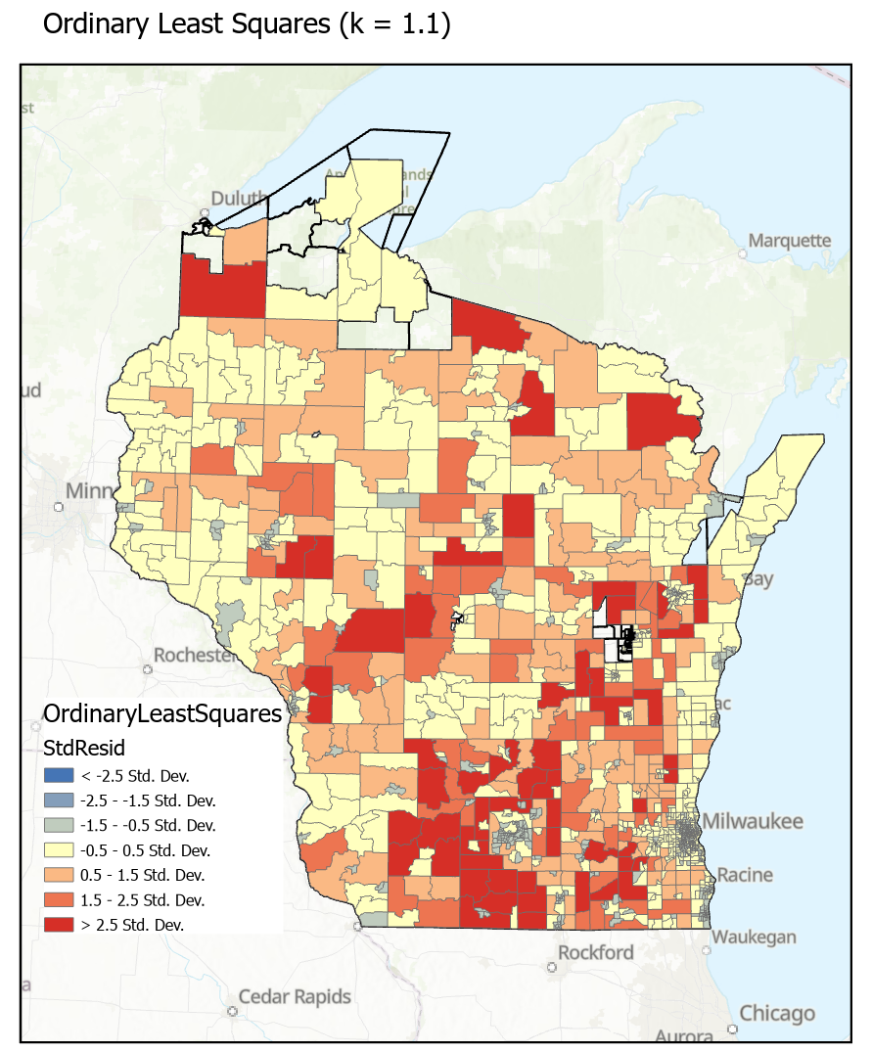
Further, the R-squared measures the performance of the model on a scale from 0 to 1. A value of 0 means the explanatory variable has no relationship to the dependent variable while a value of 1, indicating a perfect relationship. Normally, a .72 would be a good value to aim for. In this case, the analysis shows and adjusted R-squared of 0.02, which indicates the nitrates only account for 2% of the observed cancer rates.
In this study, the report for a k value of 1.1 shows an Adjusted R-squared value of 0.02 (highlighted):
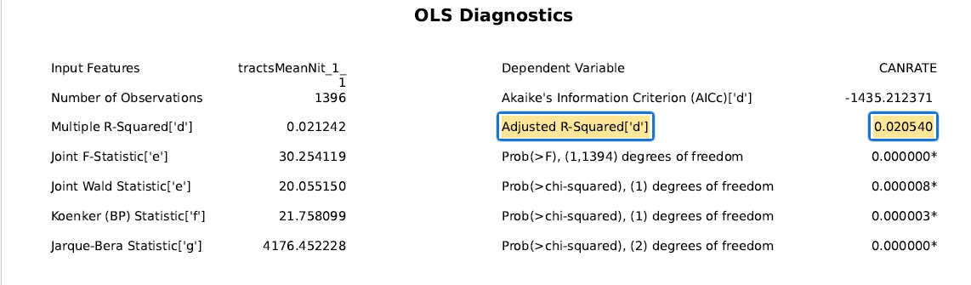
The following graph from the OLS report shows there is a very slight positive relationship between the independent variable, mean nitrate “MEANNIT” value and the dependent variable of cancer rate, “CANRATE”.
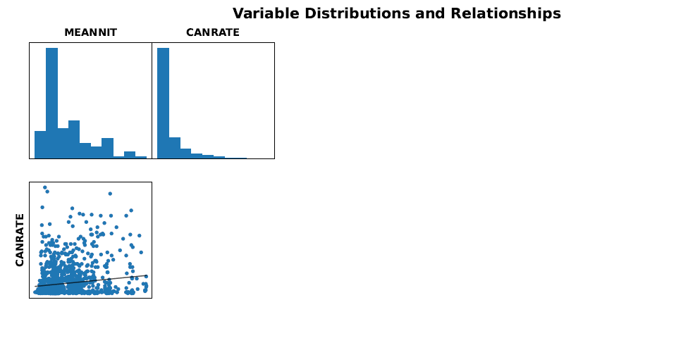
Finally, Moran’s I is used for testing for complete spatial randomness. The questions to ask are: 1. What are the chances that this pattern is random? And, 2. How likely is this pattern the result of a random spatial process? In this groundwater nitrate study, the analysis shows that the standard residuals are spatially autocorrelated.

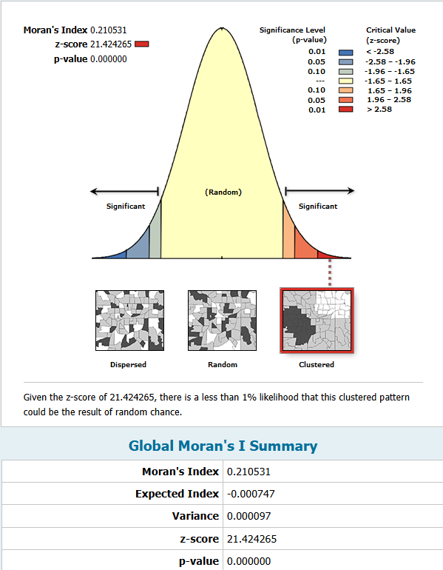
If nitrates were a significant explanation for cancer rates the Moran’s I would have shown that the standard residuals were randomly distributed. Following is an example from the Moran’s I reported values that indicates the values are clustered, “given that the z-score is 21.424265, there is a less than 1% likelihood that this clustered pattern could be the result of random chance.”
I would like to further examine the Geographically Weighted Regression, and further explore the relationship between the nitrates and cancer rates, as this is an interesting relationship to explore. A more practical tool would be an add-in tool for ArcGIS Pro, or simply run/tweak the sequence in ArcGIS Notebooks (adding\subtracting in GWR tool) without the cumbersome ArcPy/conda environment errors that would ease sharing.

Limitations and Future Work
- Model specification: OLS does not account for spatial dependence or nonlinearity. If Moran’s I is significant, a spatial regression approach is recommended.
- Covariates: cancer risk is influenced by multiple factors. Incorporating demographic, environmental, and socioeconomic variables would strengthen interpretation.
- Resolution sensitivity: results depend on raster cell size. A small sensitivity analysis across plausible cell sizes would quantify this influence.
- Usability enhancements: a concise results panel that explains coefficients, confidence intervals, and Moran’s I in plain language would aid decision makers. Automatic run logging that records $K$, cell size, model metrics, and export paths would improve reproducibility.
Conclusion
The project delivers a compact, shareable application that implements a transparent spatial workflow. By combining IDW interpolation, tract level aggregation, OLS estimation, and Moran’s I diagnostics inside a simple interface, the tool allows WDNR staff to explore the nitrate and cancer relationship with minimal setup and with outputs that can be reviewed and communicated. The framework is readily extendable to include additional covariates and spatial models in future iterations.
References
- ESRI, ArcGIS Pro documentation for arcpy.mp map automation.
- ESRI, Spatial Analyst documentation for IDW interpolation and Zonal Statistics.
- ESRI, Spatial Statistics documentation for Ordinary Least Squares and Spatial Autocorrelation, Moran’s I.
- OLS Regression: The Key Ideas Explained | DataCamp
- How OLS regression works—ArcGIS Pro | Documentation
- Ordinary Least Squares (OLS) (Spatial Statistics)—ArcGIS Pro | Documentation

